

ANNIE OAKLEY® PERFUMERY
300 Johnson Street, P.O. Box 203
Ligonier, Indiana 46767

July 10, 2012 ∙ For Immediate Release

Contact: Renee Gabet, Annie Oakley® Perfumery Owner and Founder, 260-894-7219 or Renee@AnnieOakley.com

ANNIE OAKLEY® PERFUMERY STUDIO TO HOST FIRST ANNIVERSARY GALA
Free Tours, Live Music, High Tea and Wine Tastings are Part of 3-Day Event July 25-27

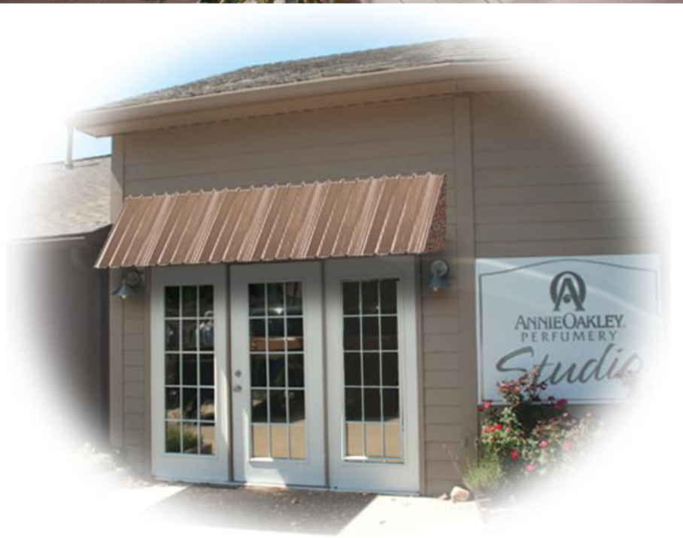
Ligonier, Ind. – Annie Oakley®, one of northern Indiana’s “tourism gems” and the only perfumery in the United States, is hosting a First Anniversary Gala event July 25-27 to celebrate the one-year anniversary of the firm’s Perfumery Studio, located at 300 Johnson Street in Ligonier. The three-day gala will feature free sensory tours daily from 10 a.m. to 1 p.m. to demonstrate how Annie Oakley® world-class perfumes are created, blended and bottled. Afternoon highlights will include high tea, pastries and fresh fruit from 3 p.m. to 4 p.m. each day, followed by jazz music and fragrance sampling from 4 p.m. to 5:30 p.m. The celebration will culminate with a special evening planned for Friday, July 27, that will feature a wine tasting with award-winning Indiana wines and French hors d’oeuvres from 5:30 p.m. to 8 p.m., and live music with a performance by Patsy Cline tribute artist Trina Wakefield from 6 p.m. to 7:30 p.m.

The anniversary gala is open to the public and free of charge. Hostess for the event will be Renee Gabet, founder and owner of Annie Oakley®, who runs the perfumery with her husband Charles Gabet and other family members. The daily agenda for the three-day celebration July 25-27 is as follows:
- 10 a.m. to 1 p.m. -- Free Annie Oakley® perfumery tours on the hour;
- 2 p.m. to 3 p.m. -- One-of-a-kind personal fragrances created by Annie Oakley’s expert perfumer;
- 3 p.m. to 4 p.m. -- High tea with fresh fruit, pastries, croissants and original French-Amish Cream Puffs™;
- 4 p.m. to 5:30 p.m. – Jazz music and Annie Oakley® fragrance sampling; and
- 5:30 p.m. to 8 p.m. (Friday only) – Wine tasting and hors d’oeuvres, and
- 6 p.m. to 7:30 p.m. (Friday only) – Performance of Patsy Cline tribute artist Trina Wakefield.

--more--
ANNIE OAKLEY ANNIVERSARY GALA (add one)

Annie Oakley® was founded in 1980 in the heart of Indiana Amish country, which draws thousands of people each week to the Shipshewana Flea Market, Amish restaurants and furniture stores, bed and breakfast inns, and other attractions.

The Annie Oakley® Perfumery Studio, a more recent addition to the Ligonier business, was named a Top 15 U.S. Route 6 Destination by Marlerie Yolen-Cohen, feature travel writer for publications such as National Geographic Travel and Newsday. Her Stay on Route 6 blog at http://stayonroute6.blogspot.com has included Annie Oakley® three times since the perfumery studio opened. In Yolen-Cohen’s most recent mention of the perfumery on January 11, 2012, the travel writer called Annie Oakley® “a little slice of Provence in the Midwest” that is “imbued . . . with fragrant panache.”

For more information on the Annie Oakley® First Anniversary Gala event, call 1-800-652-6643, or visit www.AnnieOakley.com/AnniversaryBash. The Northeast Indiana Small Business Development Center (NEISBDC) is assisting with marketing strategies for the Annie Oakley® Perfumery Studio First Anniversary Gala. To learn more about the services of the NEISBDC, visit www.isbdc.org or call 260-481-0494.

--30--
A History of Annie Oakley®
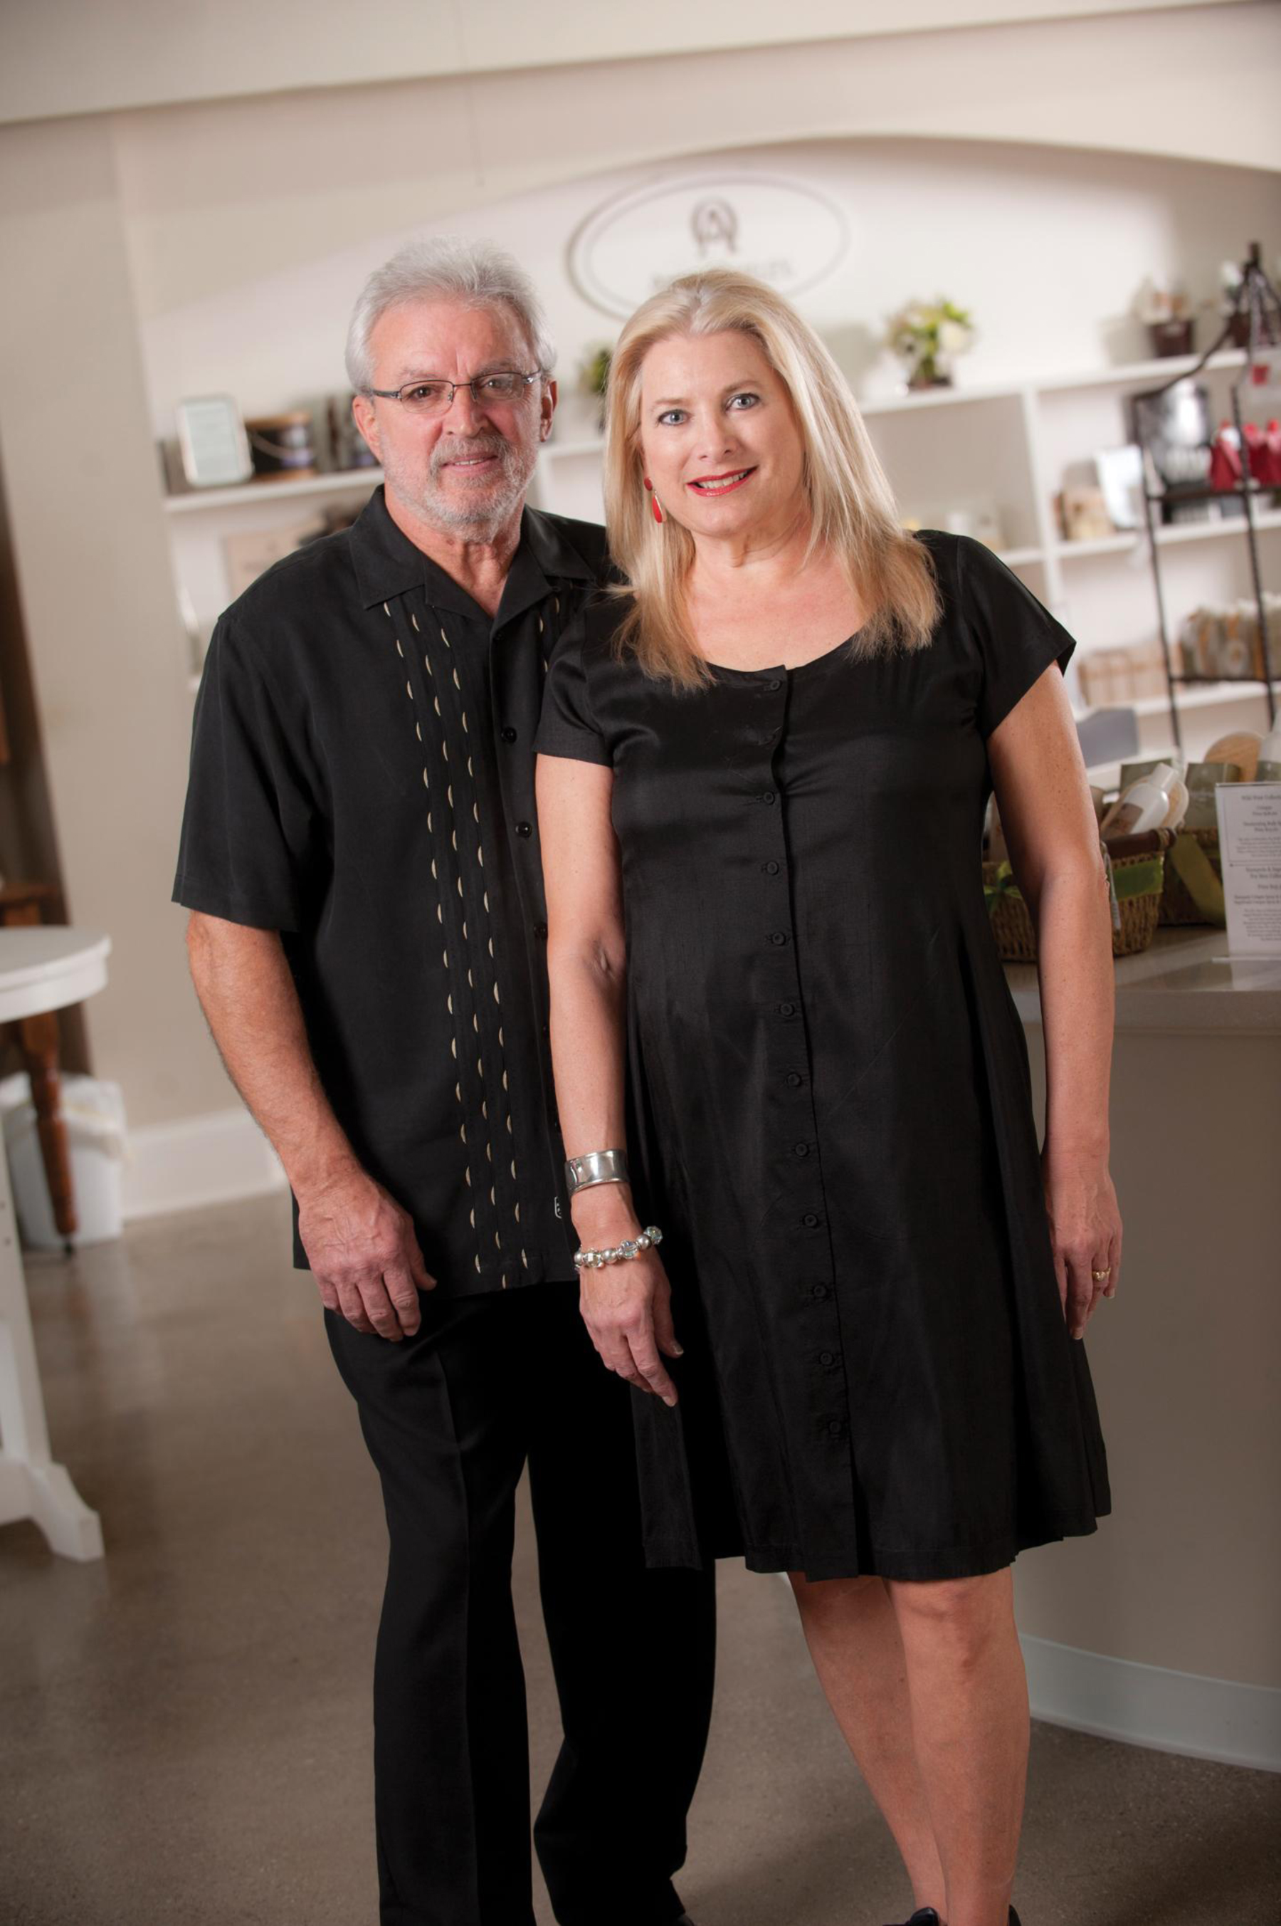
Annie Oakley®, named after the famous American sharpshooter (1860-1926) who starred in Buffalo Bill’s Wild West show, is a creator of fragrances and body products for women and men. The all-natural, organic fragrances and body products are offered include the Florals Collection, Nature’s Harvest® Collection, Stampede® for Men, Sagebrush® for Men, and the new Wild West® for Men. Annie Oakley also offers a line of pure essential oils, Eclectic Remedies®.
The company began simply in 1980 when Renee Gabet, along with her husband and five children, created and hand-blended fragrances and essential oils in the kitchen of their Ligonier home. Since that time, Renee has traveled the world in search of the finest ingredients and perfumers to assist her in creating nature-inspired Annie Oakley® fragrances.
Renee (Highlen) Gabet (pictured with her husband) is a native of Fort Wayne and a graduate of Snider High School, while her husband Charles “Chuck” Gabet is from New Haven and a graduate of Bishop Dwenger High School.
Renee traces her love of perfume back to the old Wolf & Dessauer department store in downtown Fort Wayne, where as a young girl she sampled fragrances and admired the beautiful perfume bottles on display in the store’s cosmetics department while shopping with her mother and grandmother. “I smelled all these wonderful fragrances and gained a love for perfumes,” she reminisces.
Over time, Renee expanded her small home-based business into an off-site perfumery at its current location as the Annie Oakley® products gained popularity. Today, Annie Oakley® offers a full line of natural fragrances and body products, and has sold more than 2 million bottles around the world, mainly through its 1,500 retail distributors, its perfumery studio and its online storefront at www.AnnieOakley.com. For more information about the perfumery’s product line of natural fragrances, call 1-800-652-6643, or visit www.AnnieOakley.com.

