

ANNIE OAKLEY® PERFUMERY
300 Johnson Street, P.O. Box 203
Ligonier, Indiana 46767

July 16, 2013 ∙ For Immediate Release

Contact: Renee Gabet, Annie Oakley® Perfumery Owner and Founder, 260-894-7219 or Renee@AnnieOakley.com

ANNIE OAKLEY® PERFUMERY STUDIO TO HOST ANNIVERSARY GALA JULY 24-26
Free Tours, Music, Wine Tastings and Sensory Treats to be Part of Three-Day Event

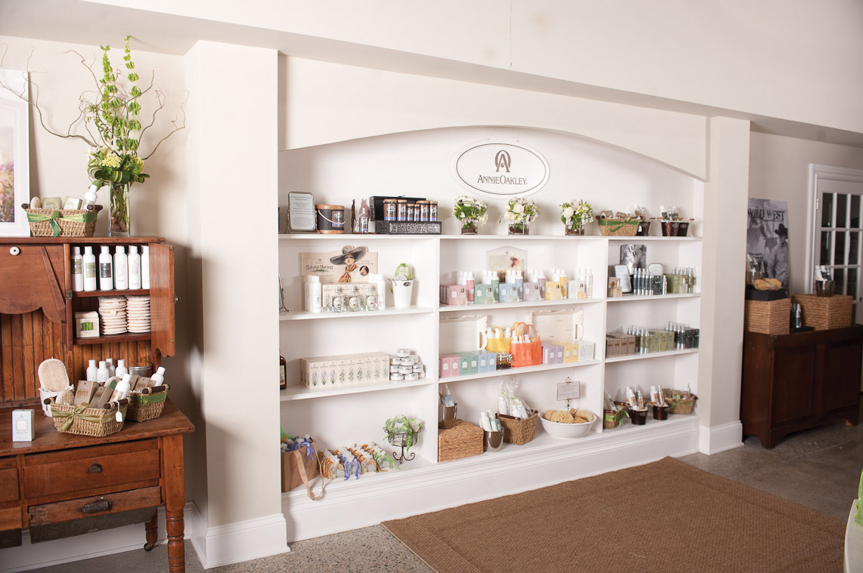
Ligonier, Ind. – Annie Oakley®, one of northern Indiana’s “tourism gems” and the only perfumery in the United States, is hosting an Anniversary Gala July 24-26 to celebrate the second anniversary of the firm’s Perfumery Studio, located at 300 Johnson Street in Ligonier. The three-day gala will feature free VIP Sensory Tours™ daily at 10 a.m., 11 a.m., 2 p.m., and 3 p.m. to demonstrate how Annie Oakley® world-class perfumes are created, blended and bottled, and to provide perfumery visitors with a sampling of rare natural fragrances. The Annie Oakley® Gift Shoppe will also be open each day of the celebration.

“Bring a friend and share the magic,” said hostess Renee Gabet, the founder and owner of Annie Oakley® who runs the perfumery with her husband Charles Gabet and other family members. “You’ll be greeted with one of our freshly-made, specialty soft drinks, such as Indy Mint™-infused lemonade, and find anniversary treats, prizes and surprises.” The anniversary gala is open to the public and free of charge. The daily agenda for the three-day celebration is as follows:

- All Three Days, July 24-26—Annie Oakley® Perfumery Studio will be open from 10 a.m. to 5 p.m. Free Annie Oakley® perfumery VIP Sensory Tours™ will start on the hour at 10 a.m., 11 a.m., 2 p.m., and 3 p.m., offering a sensory journey of organic, rare and vintage natural fragrances from around the world.
- Thursday and Friday, July 25 and 26—From noon to 5 p.m., one-of-a-kind personal fragrances will be created by Annie Oakley’s professional perfumers.
- Friday, July 26—From noon to 5 p.m., wine tasting featuring award-winning Indiana wines.

—more—
ANNIE OAKLEY (add one)

A variety of music is planned for the three-day gala, featuring tunes from Frank Sinatra to Earth Wind & Fire and everything in between. “We welcome guest musicians to come and play during our anniversary gala,” Gabet said. Interested musicians should call 260-894-7219 or e-mail Tours@AnnieOakley.com with available times and the instrument played.

Annie Oakley® was founded in 1980 in the heart of Indiana Amish country, which draws thousands of people each week to the Shipshewana Flea Market, Amish restaurants and furniture stores, bed and breakfast inns, and other attractions.

The Annie Oakley® Perfumery Studio, a more recent addition to the Ligonier business, was named a Top 15 U.S. Route 6 Destination by Marlerie Yolen-Cohen, feature travel writer for publications such as National Geographic Travel and Newsday. Her Stay on Route 6 blog at http://stayonroute6.blogspot.com has included Annie Oakley® three times since the perfumery studio opened. In Yolen-Cohen’s most recent mention of the perfumery on January 11, 2012, the travel writer called Annie Oakley® “a little slice of Provence in the Midwest” that is “imbued . . . with fragrant panache.”

For more information on the Annie Oakley® First Anniversary Gala event, call 1-800-652-6643.
--30--

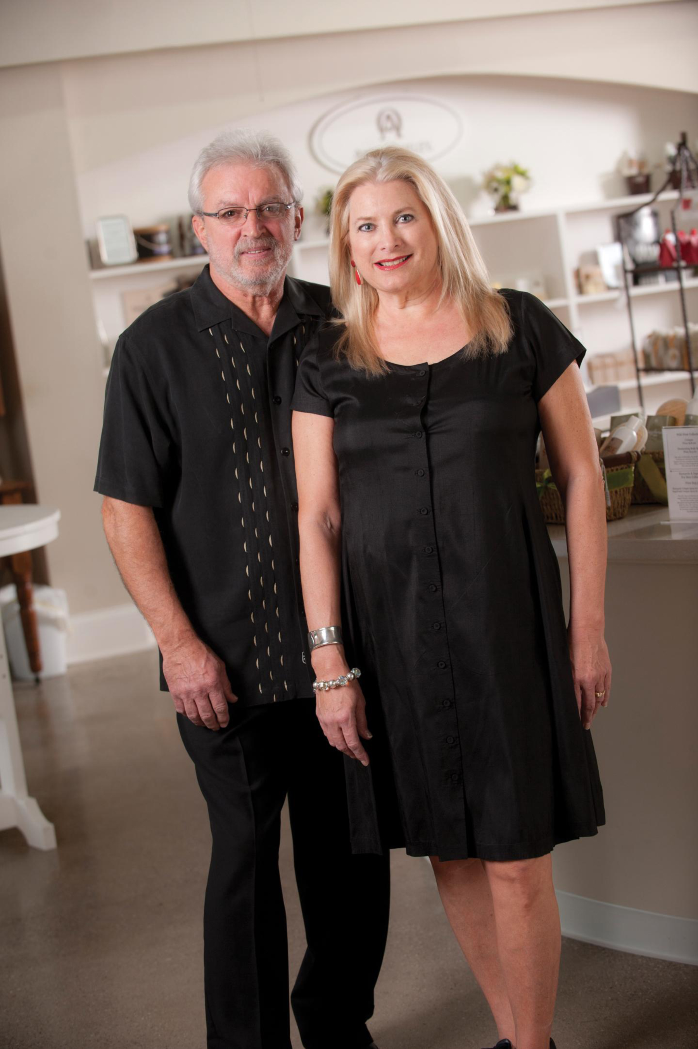
A History of Annie Oakley®
Annie Oakley®, named after the famous American sharpshooter (1860-1926) who starred in Buffalo Bill’s Wild West show, is a creator of fragrances and body products for women and men. The all-natural, organic fragrances and body products include the Florals Collection, Nature’s Harvest® Collection, Stampede® for Men, Sagebrush® for Men, and the newest collection, Wild West® for Him and Her. Annie Oakley also offers a line of pure essential oils, known as Eclectic Remedies®.

The company began simply in 1980 when Renee Gabet, along with her husband Charles and five children, created and hand-blended fragrances and essential oils in the kitchen of their Ligonier home. Since that time, Renee has traveled the world in search of the finest ingredients and perfumers to assist her in creating nature-inspired Annie Oakley® fragrances.

Renee (Highlen) Gabet (pictured with her husband) is a native of Fort Wayne and a graduate of Snider High School, while her husband Charles “Chuck” Gabet is from New Haven and a graduate of Bishop Dwenger High School.
.

